**Small Computing Devices – Raspberry Pi, Arduino and Makey Makey**

**Raspberry Pi**

The Raspberry Pi is a very affordable, tiny, yet fully fledged computer not much bigger than a credit card.

Originally released back in 2012, the Raspberry Pi has seen a number of iterations and consequent improvements in hardware and connectivity.

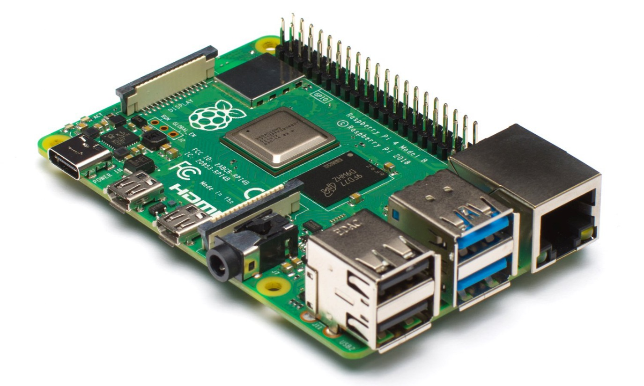

(Pictured is the Raspberry Pi 4 Model B. PiAustralia, 2020)

**Iterations & Specs**

The Raspberry Pi 1 initially offered four variants which included a single-core CPU. Among the variants were options for 256 megabytes or 512 megabytes of memory, between one and four USB 2.0 ports, either an SD card slot or Micro SD card slot. Two variants offered Ethernet connectivity.

The Raspberry Pi 2, released in 2015, offered a drastic boost in performance, offering a higher frequency quad-core CPU, and 1GB of memory.

The Raspberry Pi 3, released in 2016, increased performance further through a higher CPU frequency; it also included WiFi N & Bluetooth 4.1 connectivity.

**The latest iteration**, the Raspberry Pi 4 Model B, was released in June 2019; it again has increased the frequency of the CPU offering further performance gains, as well as 2GB, 4GB or 8GB of LPDDR4 memory. Connectivity includes: WiFi AC & Bluetooth 5, Gigabit Ethernet, two USB 3.0 ports, and two USB 2.0 ports. A monitor with up to 4k Resolution at 60 Hz is supported via the micro HDMI port. The model with 2GB of RAM is available for $75 AUD.

Various accessories can be bought for the Raspberry Pi such as camera modules and add-on boards which extend its functionality further.

The Raspberry Pi runs Raspberry Pi OS (which was previously called Raspbian). It is also capable of running other flavours of Linux.

According to a tweet from Ebon Upton as cited on Wikipedia, they had sold 30 million units by December 2019. (**Not sure how to cite this... but it's found in the link below)**

<https://en.wikipedia.org/wiki/Raspberry_Pi>

The Raspberry Pi can be used for a variety of different purposes such as studying coding, computers & hardware and their interactions, creating personal projects, and it can even be used as a low-cost PC.

According to an article written by Ashutosh KS (2019), a number of cool projects have been created with the Raspberry Pi:

* Twitter Bot with a Raspberry Pi & Python
* Raspberry Pi Portable Games Console
* Raspberry Pi Home Automation
* Building Robots with Raspberry Pi & Python
* Security Camera Network with Raspberry Pi

**The Pi in education**

The Raspberry Pi is produced by the Raspberry Pi Foundation who originally produced the Pi to promote the studying of computer science, primarily in schools.

*"[T]he lack of programmable hardware for children – the sort of hardware we used to have in the 1980s – is undermining the supply of eighteen-year-olds who know how to program, so that's a problem for universities, and then it's undermining the supply of 21 year olds who know how to program, and that's causing problems for industry.*

*Co-founder Eben Upton in 2012"* (**attribute this to this guy but also Wikipedia where it was found**)

**Arduino**

An Arduino is a programmable micro-controller – a printed circuit board, in other words. It can be connected to a computer to be programmed to perform different operations. The IDE (integrated development environment) – which is software that enables the user to program the Arduino – uses a simplified version of C++ which is a popular low-level language.

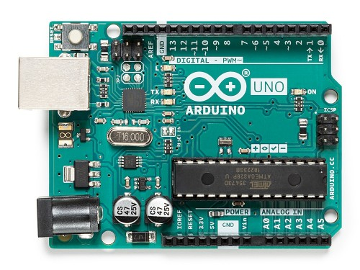

(<https://store.arduino.cc/usa/arduino-uno-rev3>)

An Arduino can be used to power any number of different types of electronics projects. It contains pins which you can use to build a circuit by connecting wires.

**Makey Makey**

The Makey Makey is a device targeted towards teaching children and adolescence the basics of electronics. It is a fun, creative and safe way to experiment with conductivity and circuit building. You can connect the alligator clips provided with the Classic model to use a number of common items found around the house such as bananas, playdough, and much more, to control your computer's keyboard and mouse, as well as trigger other inputs.

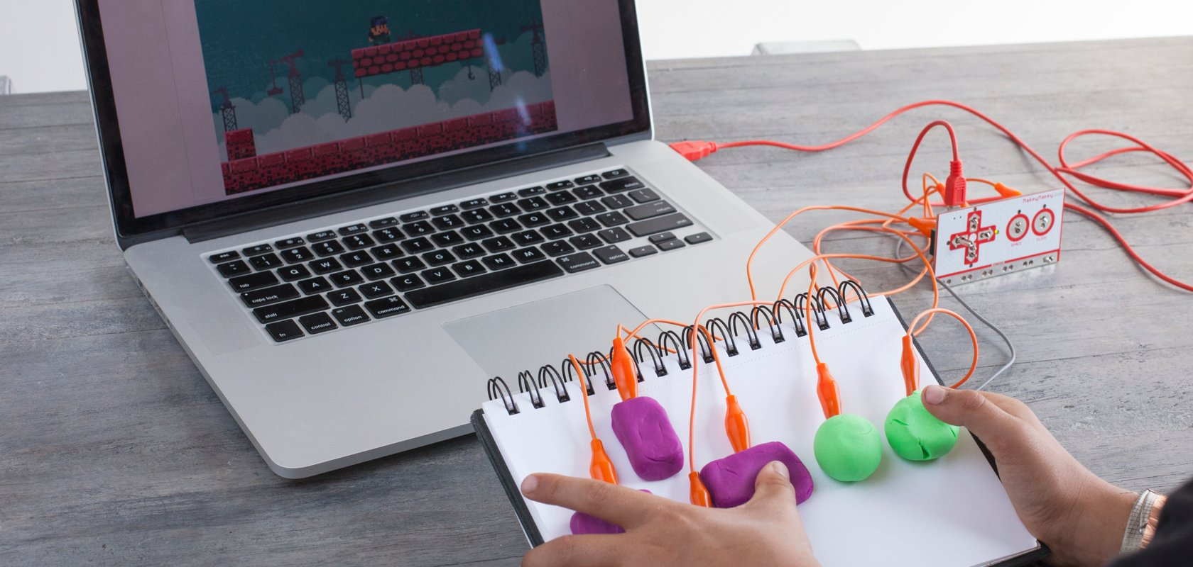

(makeymakey.com)

The Makey Makey Classic works by opening and closing circuits and supports up to 18 different button inputs, whereas the Makey Makey Go works with capacitance and is more suitable for single button projects.

The device is powered by USB and only uses a minimal amount of voltage (50 microamps), thus it is completely safe for human contact, which is especially important around children.

The Makey Makey website includes an assortment of lessons such as "Craft a Simple Circuit", "Draw a Playable Instrument", "Craft and Code Interactive Stories" and more.

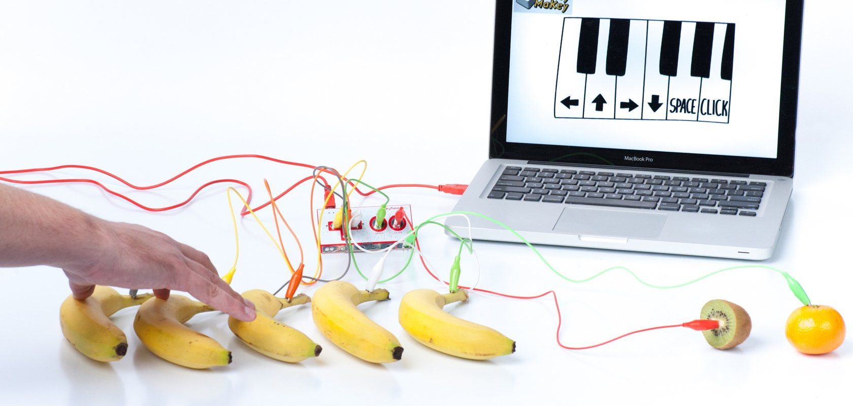

(makeymakey.com)

**What is the likely impact of these devices?**

Due to the low price of the Raspberry Pi, people in third world countries where computers are less common or even almost non-existent, are more able to afford a computer for personal use and study. In particular, its usage in schools for education in these countries is game-changing and there are a number of charities and not-for-profit organisations that aim to bring computers to these countries.

The Raspberry Pi, Arduino and Makey Makey are great for children or students learning about computers, hardware and software interaction, and much more.

In first world countries, the result is an increased interest in computers, electronics and how they work – spurring on the next generation to gain new interest into how technology works, rather than just consuming content. In third world countries, the impact is potentially more significant in that, children and even adults who were previously unable to learn about or interact with computers or electronics, are now able to do so which can have a huge influence on their life and career path.

All together these devices will increase interest in programming and engineering, increasing job interest in these areas.

**The Pi has been found to be very useful in third world countries**

Back in 2009, a charity by the name of World Possible started working on the RACHEL web server – RACHEL stands for "Remote Area Community Hotspots for Education and Learning".

Its purpose was to allow a number of important educational resources from a variety of sources such as Wikipedia, Khan Academy, school books, medical first-aid information and much more, to be distributed via a local web server to any connected computers – it is essentially, a compilation of essential resources from the internet, which can be accessed through a web browser on the local network. (Upton, 2014)

The release of the Pi was game-changing because it allowed the web server to be hosted from, and accessed by, a very low cost and low power computer.

Some examples of Pi usage:

In Ghana, Western Africa, 6 Raspberry Pis were installed in a classroom to enable computer-access; one of the Pis was setup as a RACHEL educational server, providing them with access to important educational content.

In Togo, Western Africa, a computer room was setup with 21 Raspberry Pis for daily use by the local school. Helen Lynn (2014) noted that 75% of teachers in the area had not used a computer prior to 2012.

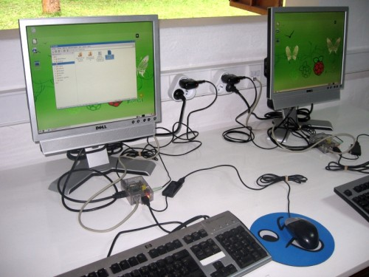

(Raspberrypi.org, 2014)

The article noted that Dominique Laloux and his team had previously built a small building which would be Kuma Tokpli's first computer room, and were planning on building a larger computer centre in Kuma. They planned to continue improving the curriculum, with the hope of teaching the students programming further down the line.

After the first successful computer centre setup two years earlier, the team moved on to build another computer room housing 21 Raspberry Pis.

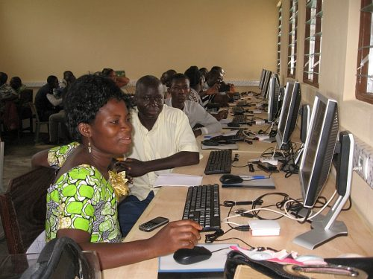

(Computer training for 25 teachers in Ghana. Raspberrypi.org, 2016)

Dominique and his team aim to raise enough money to continue adding computer rooms to various schools.

In an article by Lorna Lynch in 2016, she wrote how researchers are using the Raspberry Pi to help provide safe drinking water to third world countries that typically suffer from poor quality drinking water. This is being done through a combination of the Raspberry Pi, simple chemicals and sunlight.

**How will this affect society?**

The low cost of the Raspberry Pi makes computers an easier-to-acquire technology, where in the past, the cost was simply too great to bring computers to third world countries without significant expense. This significantly influences the education of children in such countries, and can potentially allow them to have a career in computer science.

The ability to create a low cost NAS, web server, or home security system is very appealing and allows tech enthusiasts to combine their hobby and produce a practical product for themselves.

The Arduino helps tech enthusiasts to learn, prototype and even create their own projects. Combined with the Raspberry Pi, they become a very powerful combination.

The Makey Makey allows children to start learning about complicated topics and electronics, but in a fun, creative and safe way. Whether it is used by educators to teach children in school, or by parents to encourage their children to learn about this area, it is a great tool.

**References**

Raspberrypi.org. n.d. [online] Available at: <https://www.raspberrypi.org/> [Accessed 16 July 2020].

Bate, A., 2016. Building Computer Labs In Western Africa - Raspberry Pi. [online] Raspberry Pi. Available at: <https://www.raspberrypi.org/blog/building-computer-labs-in-western-africa/> [Accessed 16 July 2020].

Makey Shop. n.d. FAQ About Buying And Using Your Science And Invention Kits - Makey Makey. [online] Available at: <https://makeymakey.com/pages/faq> [Accessed 16 July 2020].

KS, A., 2019. 19 Amazing Things You Can Do With Raspberry Pi - Hongkiat. [online] Hongkiat. Available at: <https://www.hongkiat.com/blog/raspberry-pi-projects/> [Accessed 16 July 2020].

Lynch, L., 2016. Photocatalysis With A Raspberry Pi - Raspberry Pi. [online] Raspberry Pi. Available at: <https://www.raspberrypi.org/blog/photocatalysis-raspberry-pi/> [Accessed 16 July 2020].

Makerspace for Education. n.d. Makey Makey. [online] Available at: <http://www.makerspaceforeducation.com/makey-makey.html> [Accessed 16 July 2020].

En.wikipedia.org. n.d. Raspberry Pi. [online] Available at: <https://en.wikipedia.org/wiki/Raspberry_Pi> [Accessed 16 July 2020].

Pi Australia. n.d. Raspberry Pi 4 Model B. [online] Available at: <https://raspberry.piaustralia.com.au/products/raspberry-pi-4> [Accessed 16 July 2020].

Core Electronics. 2016. Raspberry Pi Boards Compared - Tutorial. [online] Available at: <https://core-electronics.com.au/tutorials/compare-raspberry-pi-boards.html> [Accessed 16 July 2020].

En.wikipedia.org. n.d. Raspberry Pi Foundation. [online] Available at: <https://en.wikipedia.org/wiki/Raspberry_Pi_Foundation> [Accessed 16 July 2020].

Upton, L., 2013. Guest Post: A Pi Lab In Rural Ghana - Raspberry Pi. [online] Raspberry Pi. Available at: <https://www.raspberrypi.org/blog/guest-post-a-pi-lab-in-rural-ghana/> [Accessed 16 July 2020].

Upton, L., 2014. RACHEL-Pi - Delivering Education Worldwide - Raspberry Pi. [online] Raspberry Pi. Available at: <https://www.raspberrypi.org/blog/rachel-pi-delivering-education-worldwide/> [Accessed 16 July 2020].

Links

<https://makeymakey.com/pages/faq>

<http://www.makerspaceforeducation.com/makey-makey.html>

<https://www.raspberrypi.org/blog/the-first-raspberry-pi-computer-room-in-togo/>

<https://www.raspberrypi.org/blog/guest-post-a-pi-lab-in-rural-ghana/>

<https://en.wikipedia.org/wiki/Raspberry_Pi>

<https://core-electronics.com.au/tutorials/compare-raspberry-pi-boards.html>

<https://opensource.com/resources/raspberry-pi>

<https://en.wikipedia.org/wiki/Raspberry_Pi_Foundation>

<https://www.raspberrypi.org/>

<https://www.raspberrypi.org/blog/tag/developing-world/>

<https://raspberry.piaustralia.com.au/products/raspberry-pi-4?src=raspberrypi>

<https://www.techrepublic.com/article/inside-the-raspberry-pi-the-story-of-the-35-computer-that-changed-the-world/>